

*BM extension Cartridge Integration guide*

*Version 23.1.0*



Table of Contents

**1. Summary** **3**

**2. Component Overview** **4**

*Functional Overview* *4*

*Limitations, Constraints* *4*

Contract 4

*Compatibility* *4*

*Privacy, Payment* *4*

**3. Implementation Guide** **5**

*Setup of Business Manager* *5*

Importing cartridges 5

Assigning cartridges to the site 7

Import of metadata 7

Service 8

*Custom Code* *8*

Perform changes in controllers 8

Perform changes in templates 12

Perform changes in resources 22

*Configuration* *22*

Customer Groups 22

Custom Site Preferences 22

*Firewall Requirements* *24*

**4. Testing** **24**

**5. Operations, Maintenance** **24**

*Data Storage* *24*

*Availability* *24*

*Failover/Recovery Process* *24*

*Support* *24*

**6. Known Issues** **25**

**7. Release History** **25**

# Summary

The Catch BM Extension Cartridge works in conjunction with the Catch LINK cartridge and allows you to quickly switch between the preset Catch LINK cartridge configurations.

This LINK cartridge contains instructions that allow you to integrate with a reference Catch application.

**Glossary**

| Term | Description |
| --- | --- |
| SFCC | Salesforce Commerce Cloud |
| Business Manager (BM) | The primary tool used to configure the SFCC platform and customer storefront  SFRA |

# Component Overview

## Functional Overview

The Catch BM Extension Cartridge works in conjunction with the Catch LINK cartridge and allows you to quickly switch between the preset Catch LINK cartridge configurations.

## Limitations, Constraints

Use of the Catch cartridge requires credentials and API keys from Catch.

### Contract

To work with the cartridge, you need to contact the Catch support service to get your personal credentials to gain access to the Catch services.

## Compatibility

The cartridge is designed for Salesforce Commerce Cloud API version 23.9 (Compatibility Mode: 22.7).

## Privacy, Payment

The Catch cartridge doesn't collect and processes user profile information or billing information. For additional privacy information, please contact your Catch Account Manager.

# Implementation Guide

## Setup of Business Manager

### Importing cartridges

1. Download the cartridge source code.
2. Establish a new digital server connection with your SFCC Instance
3. Import cartridges to a workspace in Salesforce UX Studio.  
   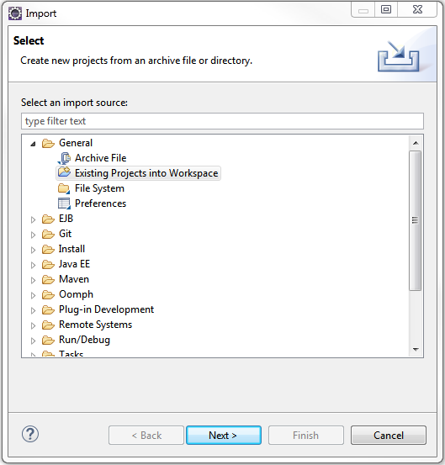
4. Add cartridges to Project Reference of Server Connection.  
   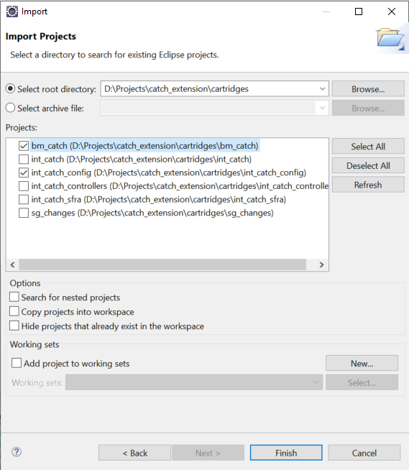
5. Wait until Studio completes workspace build and uploads source codes to the sandbox.

### Assigning cartridges to the site

Go to Administration > Sites > Manage Sites > Select your site from the list “Storefront Sites”.  
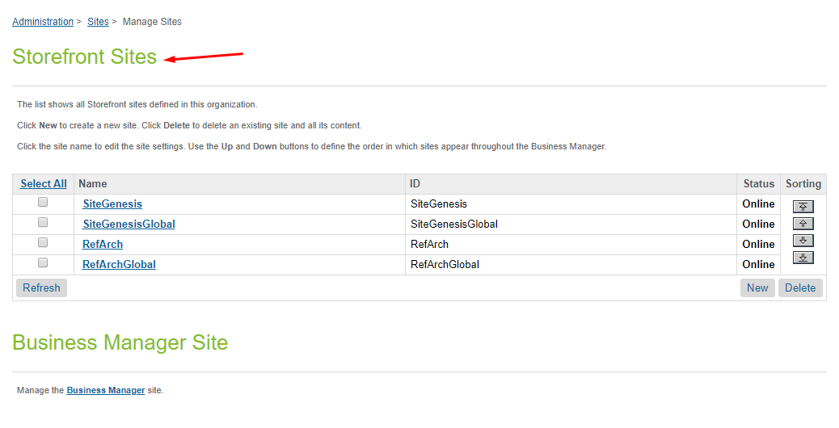  
  
Select Settings tab. In the beginning of the cartridge path add the following:  
int_catch_config:  
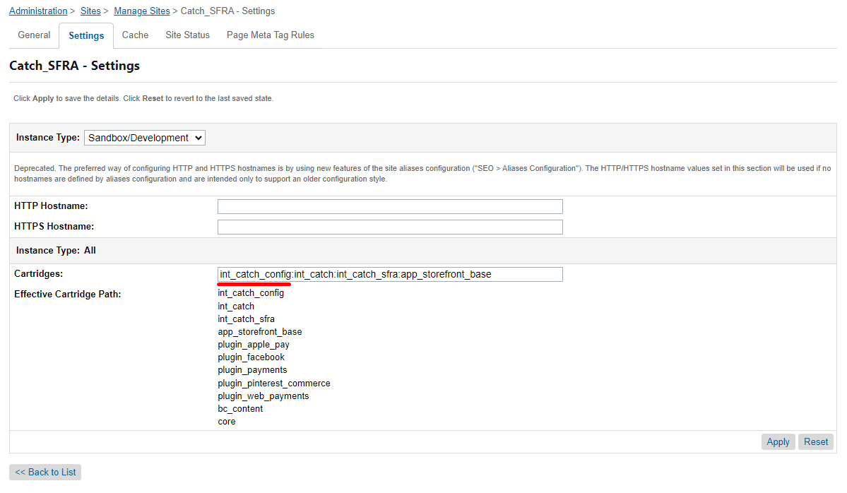

### 

### Add the cartridges to Business Manager

Go to Administration > Sites > Manage Sites > Select Manage the Business Manager site.

In the beginning of the cartridge path add the following:

int_catch_config:bm_catch:

separated by a colon(:) and click on the Apply button

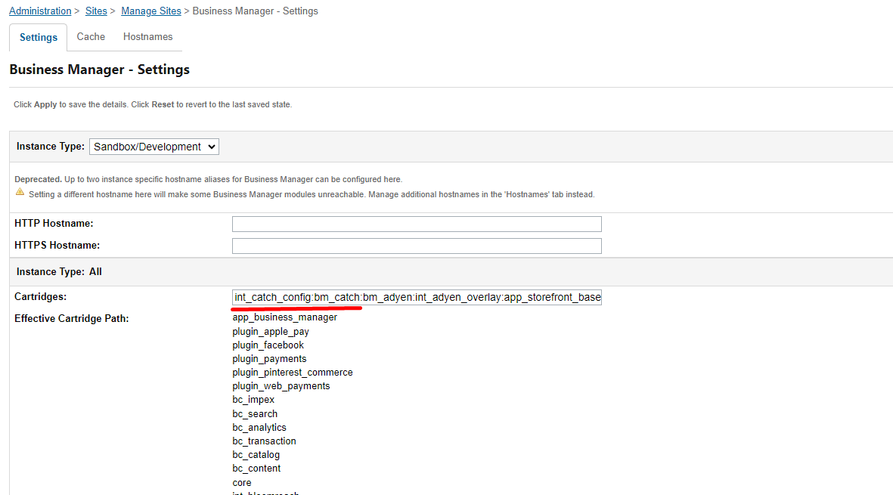

### Import of metadata

Go to Administration > Site Development > Import & Export. Upload *system-objecttype-extensions.xml* from the metadata/catch-config-pluginfolder.

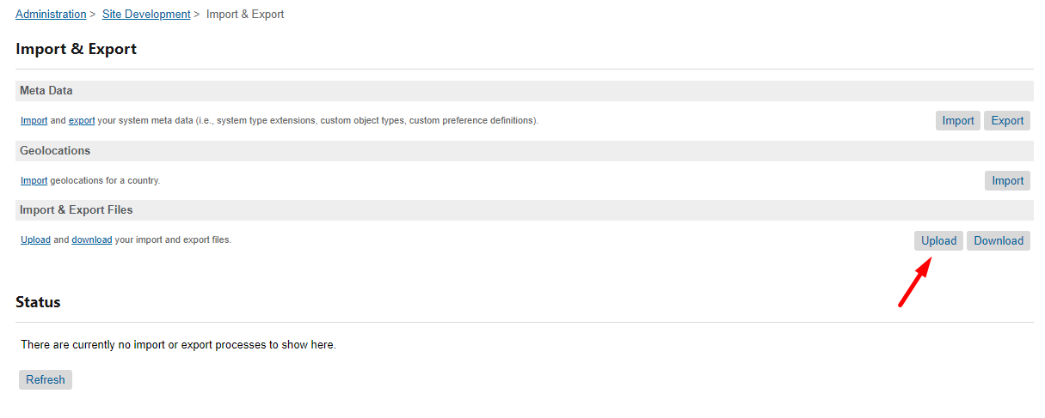

Go to the import metadata section

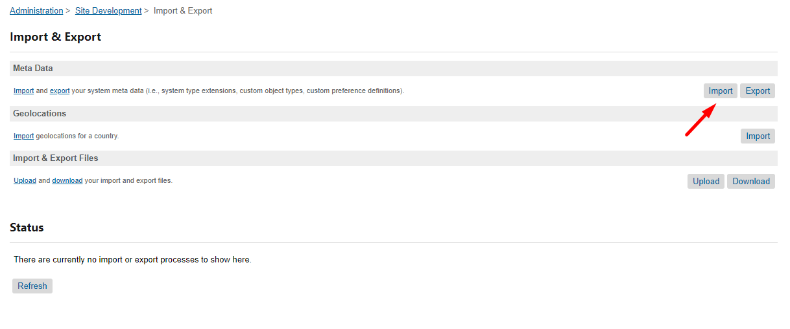

Select metadata and finish the import process.

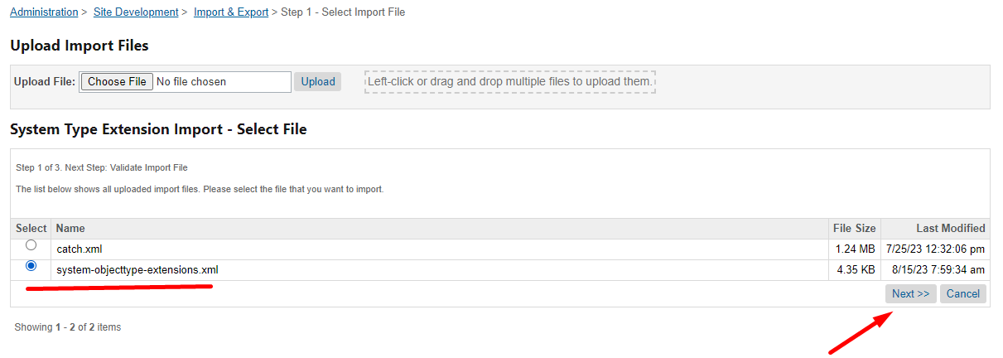

### Add Catch BM extension to the BM menu.

Go to Administration > Organization > Roles & Permissions menu and select Administrator.

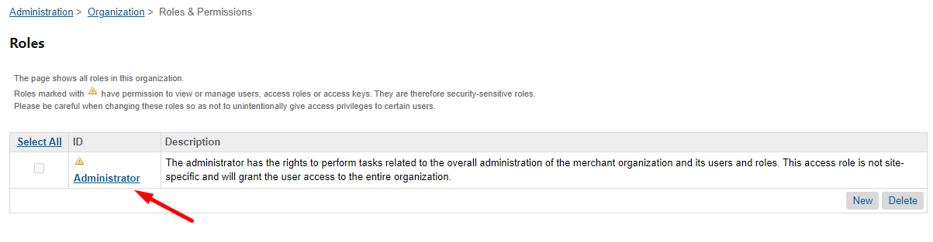

Select Business Manager Modules tab.

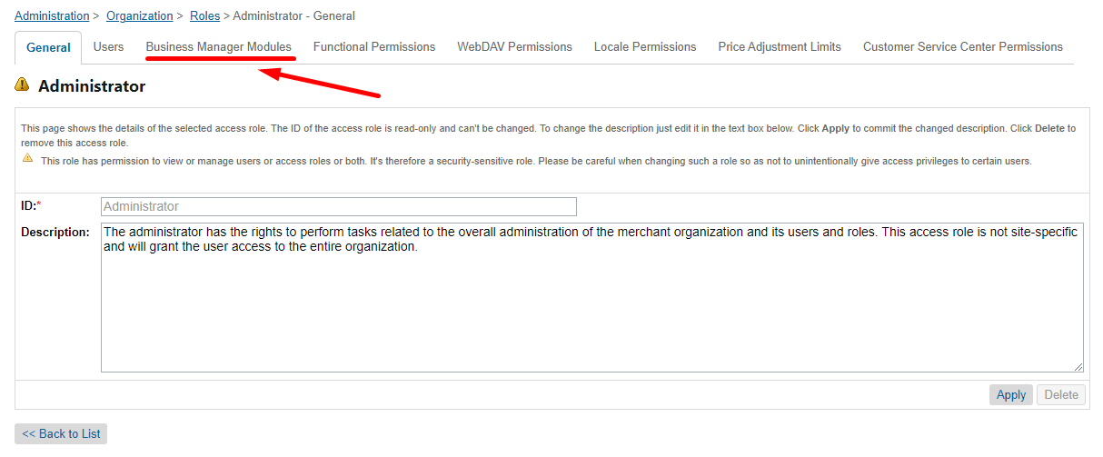

Select the sites for which you want to install the extension

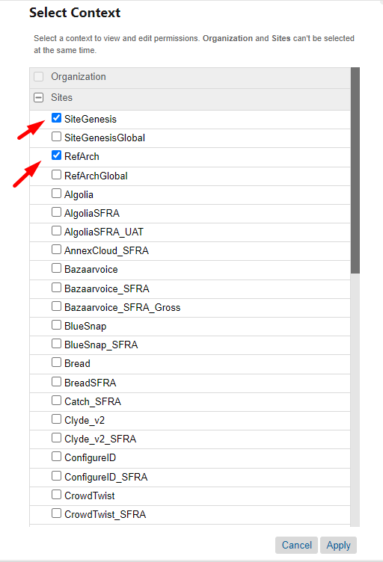

In the Site Preferences section of the table set CatchConfig and click the Apply button.

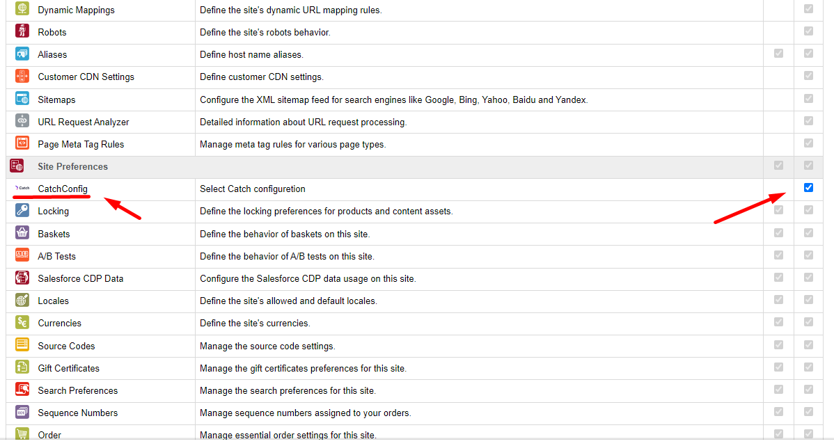

Refresh BM page. In the Merchant Tools menu you can see the CatchConfig menu item.

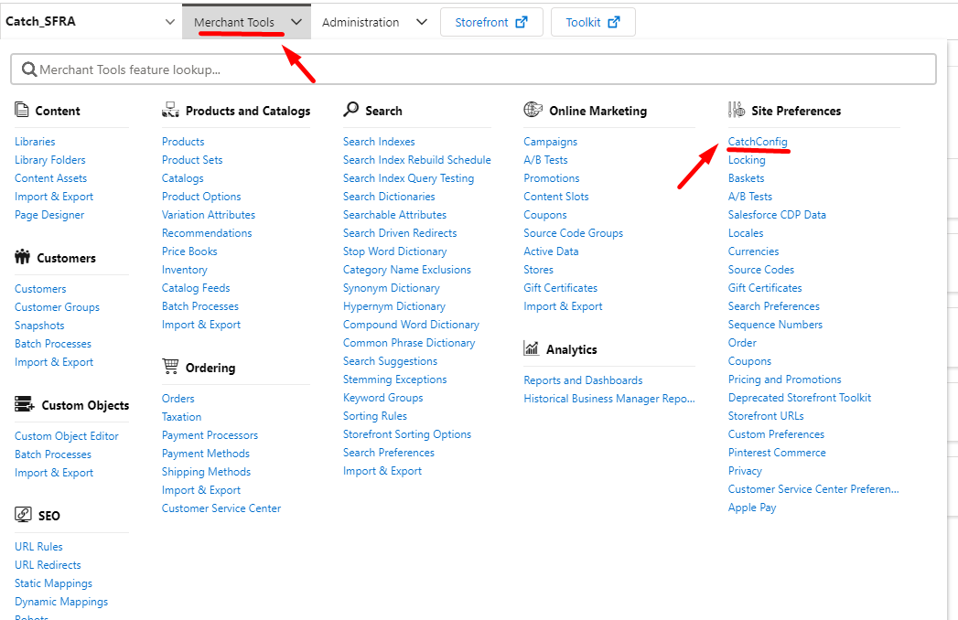

## Configuration

### Custom Site Preferences

After import is successfully done, you should see Site Preferences in BM > Merchant Tools > Site Preferences > Custom Preferences.

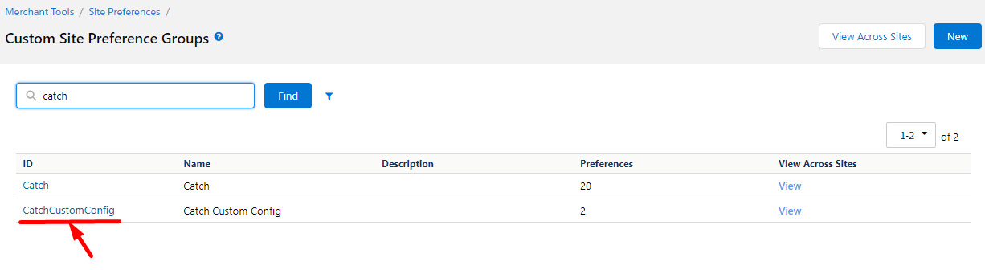

Select CatchCustomConfig and you should see fields for cartridge setup.

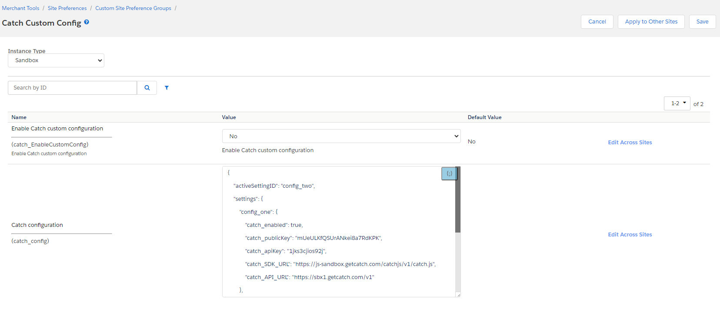

| # | Field Title | Description |
| --- | --- | --- |
| 1 | Enable Catch custom configuration | Enable/Disable using CatchCustomConfig functionality. |
| 2 | Catch configuration | Catch custom configuration as JSON |

### 

### Catch custom configuration JSON format

You can create multiple custom Catch cartridge configurations and quickly switch between them using the BM extension. Below is an example configuration in JSON format.

{

"activeSettingID": "config_two",

"settings": {

"config_one": {

"catch_enabled": true,

"catch_publicKey": "mUeULKfQSUrANkei8a7RdKPK",

"catch_apiKey": "aaaaaaaaaaaa",

"catch_SDK_URL": "https://js-sandbox.getcatch.com/catchjs/v1/catch.js",

"catch_API_URL": "https://sbx1.getcatch.com/v1"

},

"config_two": {

"catch_enable": true,

"catch_publicKey": "pk1_mUeULKfQSUrANkei8a7RdKPK",

"catch_apiKey": "bbbbbbbbbbbb",

"catch_SDK_URL": "https://js.getcatch.com/catchjs/v1/catch.js",

"catch_API_URL": "https://sbx2.getcatch.com/v2"

}

}

}

Field description:

| Field Name | Required | Description |
| --- | --- | --- |
| activeSettingID | yes | “setting_name” of the selected set of setting in “settings” object |
| settings | yes | Sets of setting |

Each set of the “settings” has a setting “setting_name” that includes optional fields of the Catch cartridge preferences in the format "preference name": "value".

{

"activeSettingID": **"selected setting_name"**,

"settings": {

**"setting_name_1"**: {

… set of settings 1 …

},

**"setting_name_2"**: {

… set of settings 2 …

}

}

}

You can use any available Catch preferences as the "preference name". Available Catch preferences names you can see in the BM > Merchant Tools > Site Preferences > Custom Preferences, section Catch.

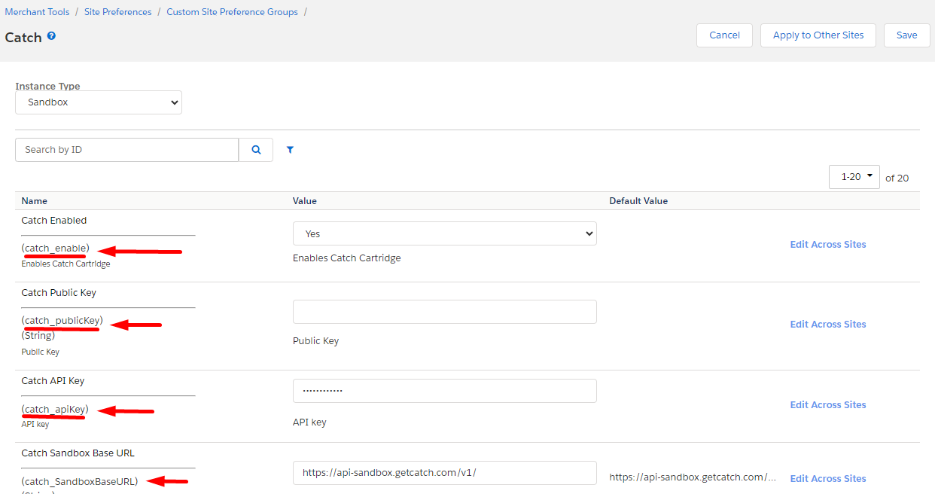

### Manage the configuration preset

Go to BM > Site Preferences > Catch Config

Set “Enable custom configuration” checkbox, select name of needed custom configuration and click the Save button. Below you can see a set of parameters and values of the selected configuration

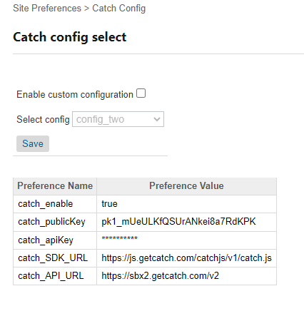

If the configuration has an invalid preference name, you will see an error message next to the corresponding row in the table.

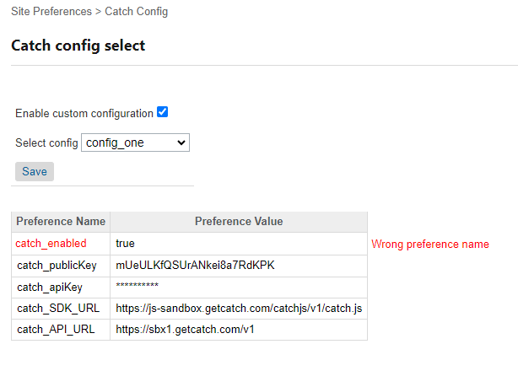

## Firewall Requirements

No special firewall requirements

# Testing

Intentionally left blank

# Operations, Maintenance

## Data Storage

Intentionally left blank

## Availability

If the Catch service becomes unavailable, the storefront continues to work without the service. All errors work of the service are saved in the log file.

## Failover/Recovery Process

Intentionally left blank

## Support

For questions please contact your Catch Success Manager.

# Known Issues

# Release History

| **Version** | **Date** | **Changes** |
| --- | --- | --- |
| 23.1.0 | 2023-08-20 | Initial release |
|  |  |  |
|  |  |  |
|  |  |  |
|  |  |  |